Predator

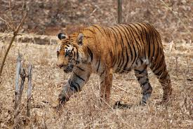

Softly he strides with total disdain,  
showing none of the hidden pain  
it must give him to be in a cage,  
to suppress his predatory rage.  
Only his constant majestic ambulation  
reveals some of his intense irritation.  
He should be prowling the open plain,  
should be showered by the cooling rain,  
be the leader of the pride,  
roam the steppes far and wide.  
The reason for this incarceration  
his keepers say, is preservation.  
The land this creature once enjoyed  
Man has nearly all destroyed.  
First we have to free his home.  
Make it safe for him to roam.  
So there he stalks from tree to tree.  
Until one day they’ll set him free.